**SUSTAINABLE OUTREACH AND UNIVERSAL LEADERSHIP LIMITED  
(SOUL)**



**STUDENT LIFE CYCLE MANAGEMENT**

**GAP ANALYSIS DOCUMENT (EXAMINATION)**

# **Introduction**

A gap analysis is an examination and assessment of the current performance for the purpose of identifying the differences between the current state of product and where you’d like to be.

Conducting a gap analysis can help us to improve our product and profitability by allowing us to pinpoint “gaps” present in our software. Once it’s complete, we will be able to better focus on our resources and energy on those identified areas in order to improve them.

# **Examination**

## **Examination Master**

### **Exam Type**

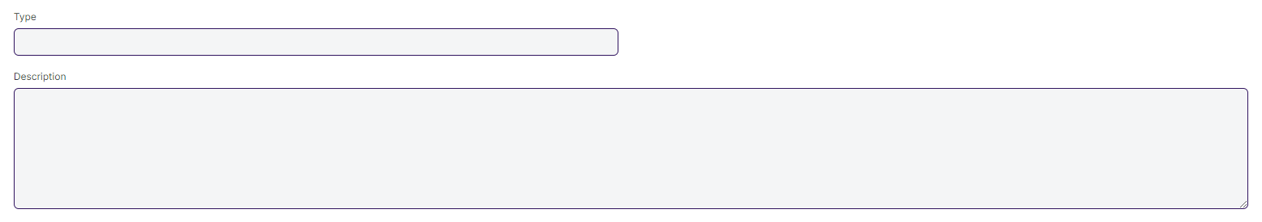

#### **Business Requirements:**

* No changes needed as discussed.

### **Assessment Criteria**

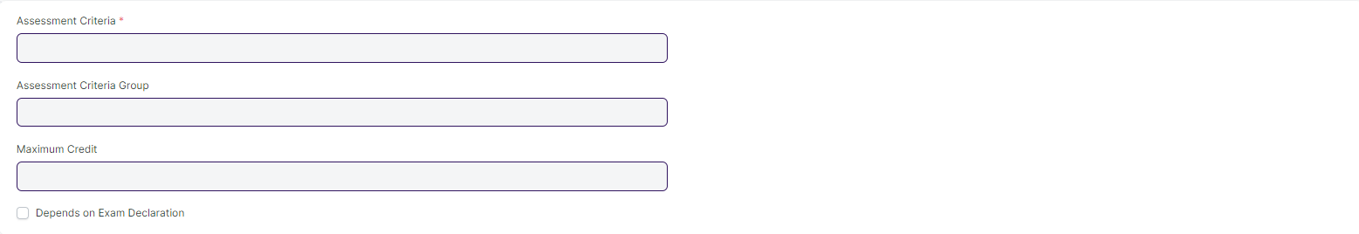

#### **Business Requirements:**

* No changes needed as discussed.

### **Grading Scale**

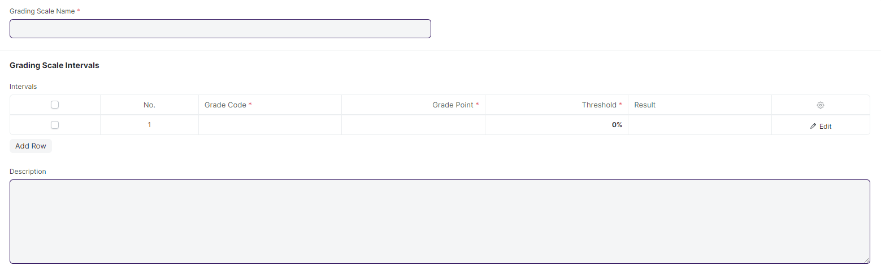

#### **Business Requirements:**

* WSC doesn’t need CGPA, they use module-wise grade

Note:

**Data changes**

The grading scale will be :

A> 80

B 70-79

C 60-69

D 50-59

F <50

### **Student Exam Block Criteria**



#### **Business Requirements:**

* No changes needed as discussed.

## **Examination**

### **Exam Declaration**

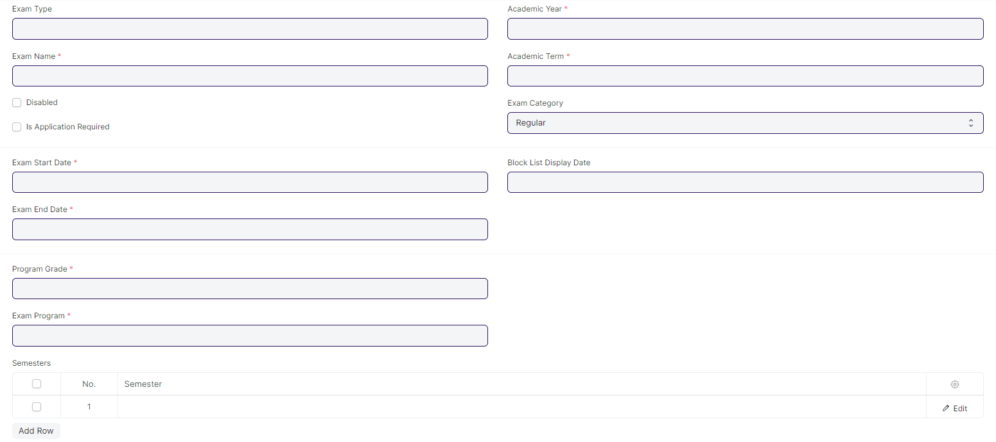

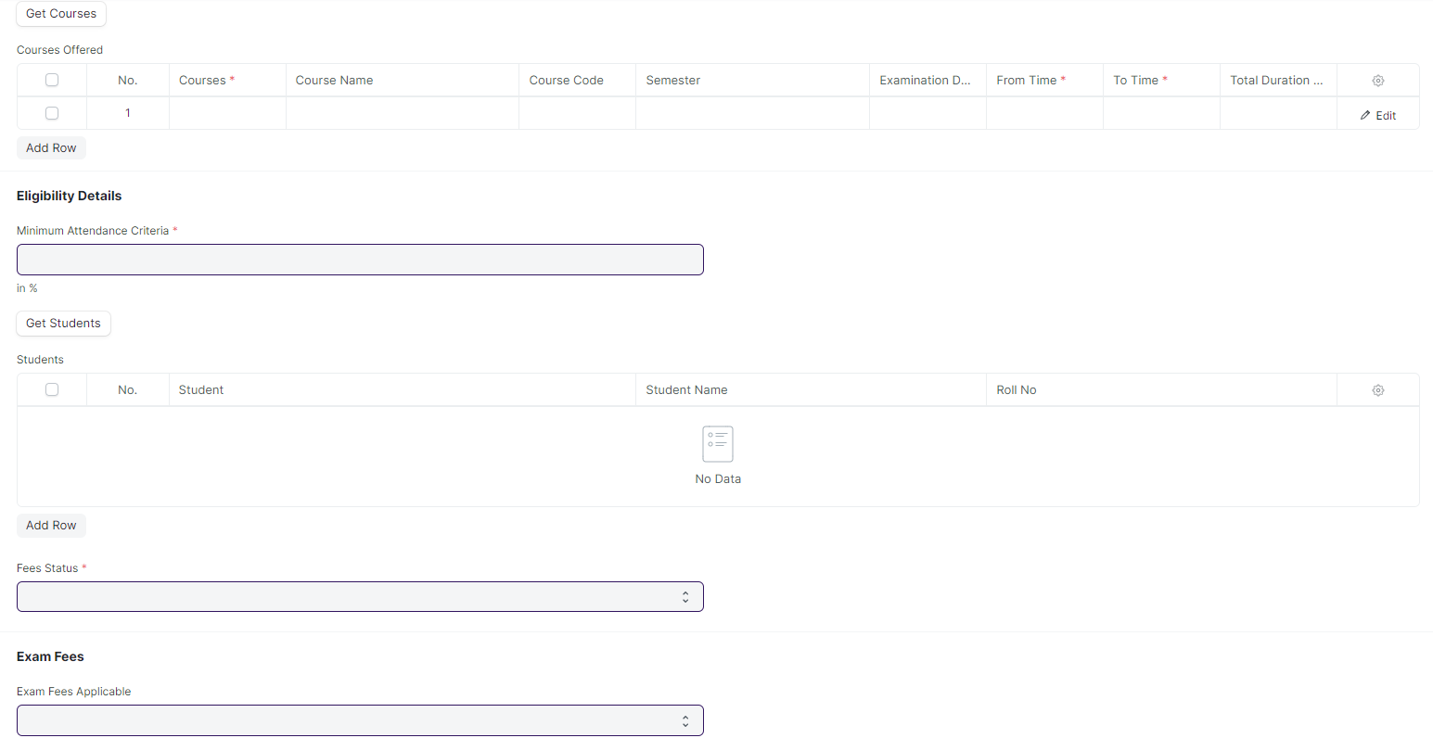

#### **Business Requirements:**

* One field must be added to the course offered table of the **Exam Declaration** screen to identify the conducting venue for their respective courses.
* A provision to assign an invigilator, a marker, and a checker should be included in the exam declaration screen for a specific course.
* Renaming of labels from Program grade, Exam program, Get courses, and Courses Offered to Course Grade, Exam Course, Get Modules, and Modules Offered respectively. Similarly, field label renaming in Courses Offered child table from Courses, Course Name, and Course code to Modules, Modules Name, and Modules Code respectively.
* If a student fails either semester 1, they will have to take a retest before the start of semester 2.
* Need to make a reminder for students and instructors regarding exams and send it before a certain time period. It should be applicable for both In-Module/End-Module. Also, reminder notifications could be sent to students /instructors prior to exam
* One of the user roles will be exam co-coordinator
* For attendance sheet, format must be the same across multiple modules but will have the name of respective modules, dates , student names and course name.
* Also must have a provision for downloading the template and student will sign in the attendance sheet.
* Once the semester starts, exam schedule is provided to the students within 15/30 days
* In-module academic calendar is issued 1 month prior to semester.
* The attendance Sheet will have Sl.No , name and sign (hard copy where students might sign) SOE - 4 courses, SOS - 2 courses. 1 academic year will have 2 semesters .Each semester is of 6 month duration.

### **Exam Application**



#### **Business Requirements:**

* If a student fails either Semester I, they will have to take a retest before the start of Semester II.

### **Exam Paper Setting**

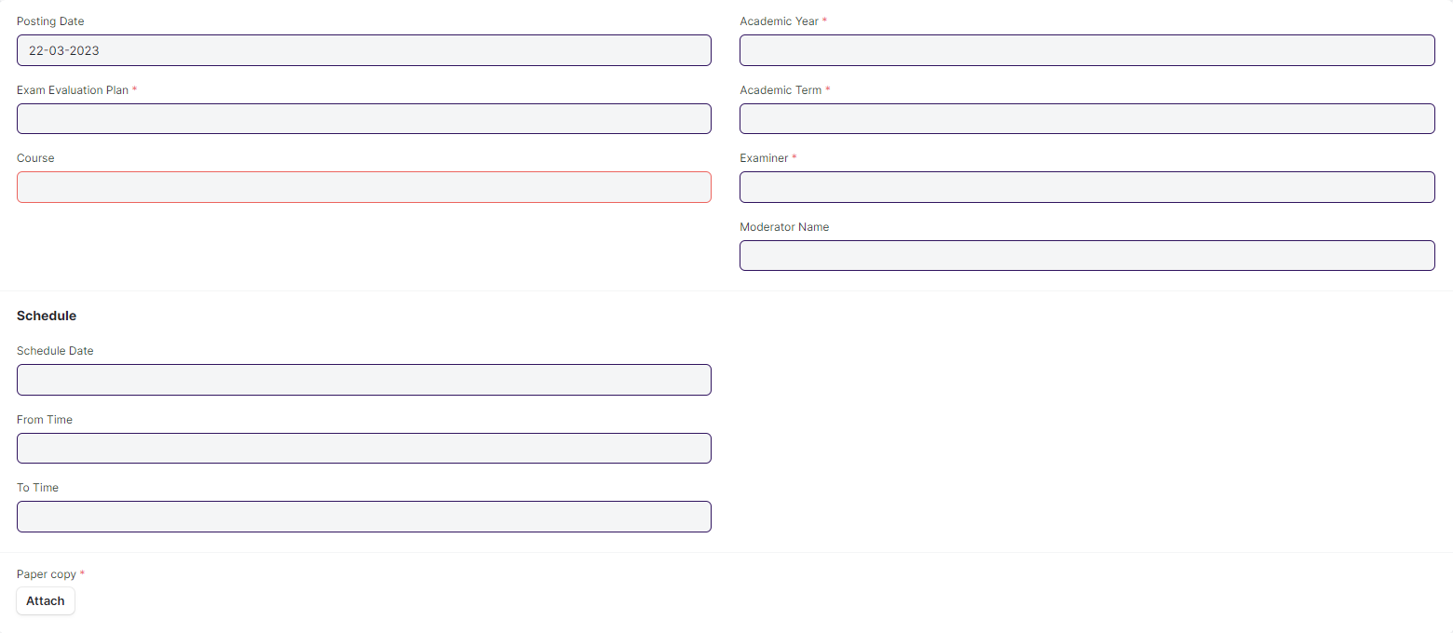

#### **Business Requirements:**

* After the paper setter and moderator list is published (via mail message will be sent to every paper setter and moderator regarding their respective courses), the paper setter will take three weeks to set the paper, and the moderator will take one week to check the paper sets.
* Once the paper setter created the paper sets,
* Then reminder sent to the director and Examination Head for review through mail
* Paper sets needs to be approved either by director or Examination Head
* Mail will be triggered to the paper setter and director when approved by Examination Head or mail will be triggered to the paper setter and Examination Head when approved by Director, then only it will be a viable exam question paper.

### **Student Admit Card**

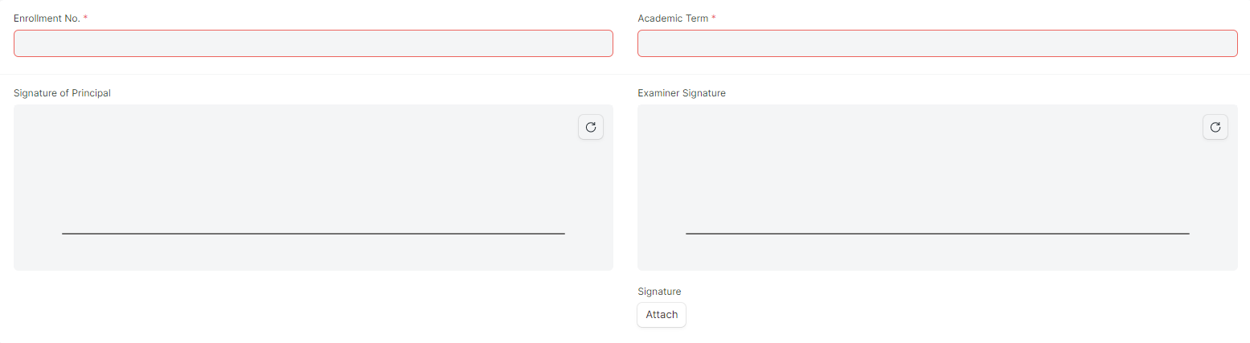

#### **Business Requirements:**

* This screen is not required.

## **Evaluation**

### **Exam Evaluation Plan**

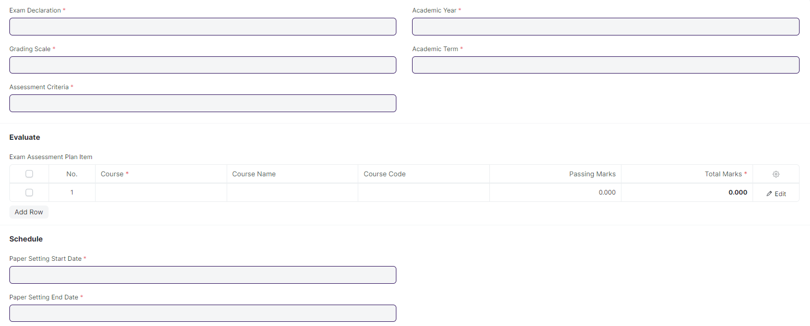

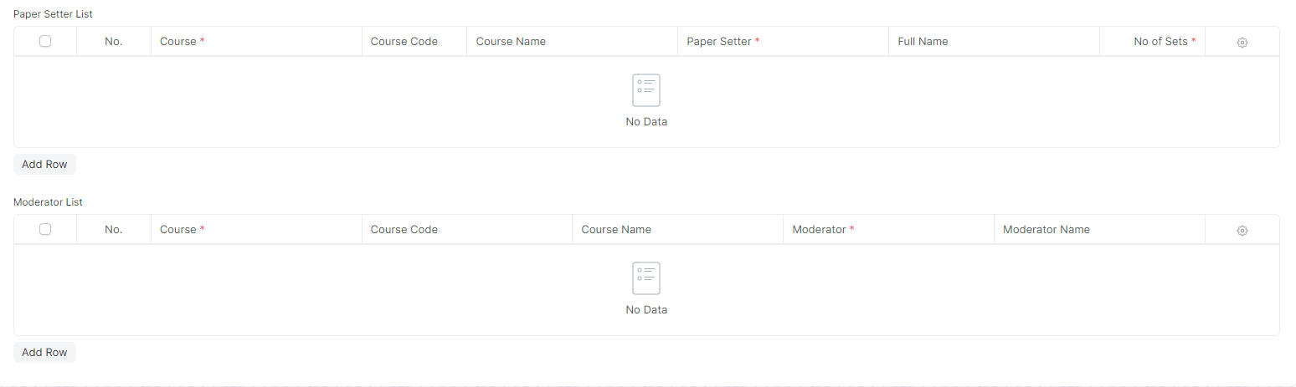

#### **Business Requirements:**

* Renaming of label from Programs to Course. Similarly in the associated child tables renaming of labels required for Course, Course Name, and Course Code to Module, Module Name, and Module Code.

### **Criteria Wise Evaluation**

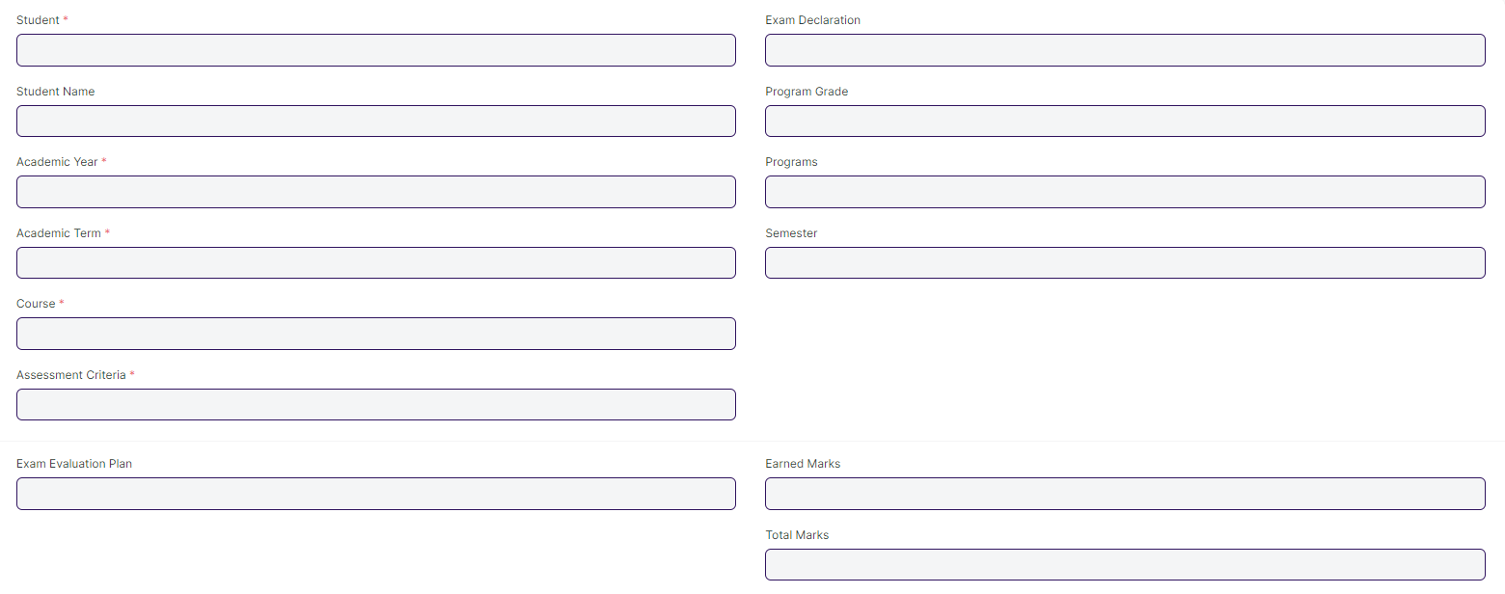

#### **Business Requirements:**

* Renaming of labels is required for Course, Course Name, Course Code, Program Grade, and Programs to Module, Module Name, Module Code, Course Grade, and Course respectively.

### **Continuous Evaluation**

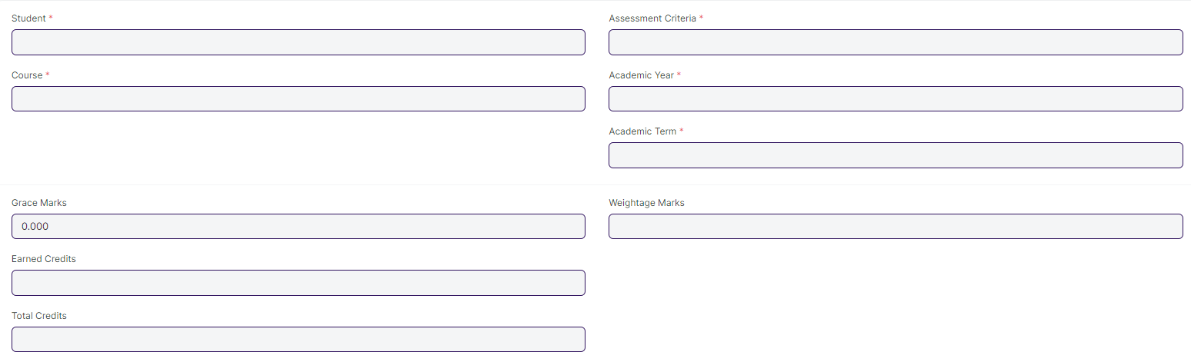

#### **Business Requirements:**

* Renaming of labels is required for Course, Course Name, and Course Code to Module, Module Name, and Module Code respectively.
* Note:

**Data Change**

The weight-age for In-module is 60% and End-module is 40%

### **Final Exam Result**

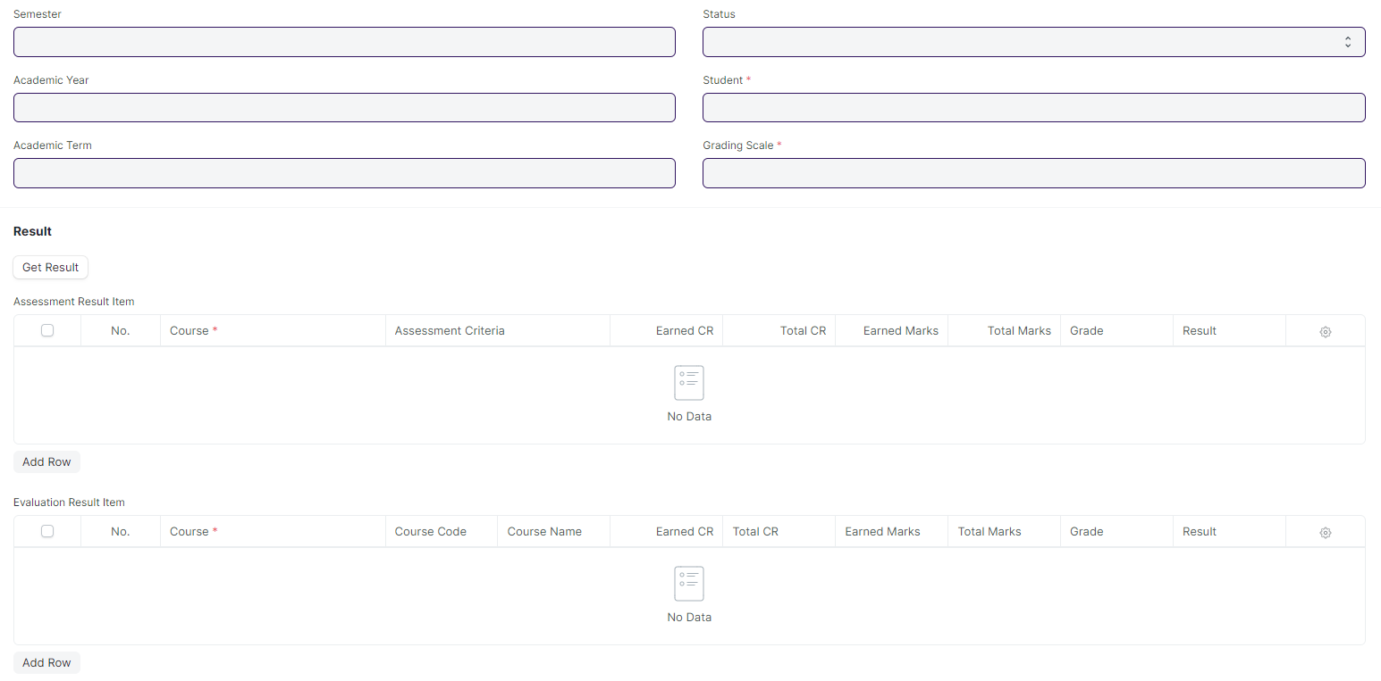

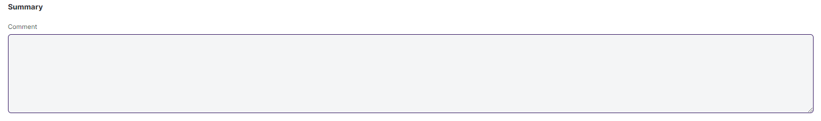

#### **Business Requirements:**

* Remove/Hide the CGPA, SGPA, and Credit features from the Final Exam Result and display the percentage and grade instead.
* Students must have access to view their results/reports
* A pictorial representation of student’s final results is required
* If a student is absent or failed during a semester exam, then student's data such as next program enrollment should not affect.
* Renaming of labels is required for Course, Course name, Course Code and Programs to Module, Module Name, Module Code, and Course respectively.

## **Tools**

### **Criteria Wise Evaluation Tool**

#### **Business Requirements:**

* Renaming of labels is required for Course, Course Name, Course Code, Program Grade, and Programs to Module, Module Name, Module Code, Course Grade, and Course respectively.

### **Continuous Evaluation Tool**

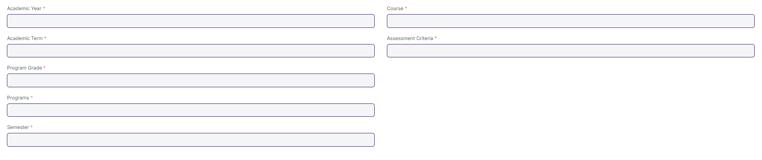

#### **Business Requirements:**

* Renaming of labels is required for Course, Course Name, Course Code, Program Grade, and Programs to Module, Module Name, Module Code, Course Grade, and Course respectively.

### **Final Result Declaration**

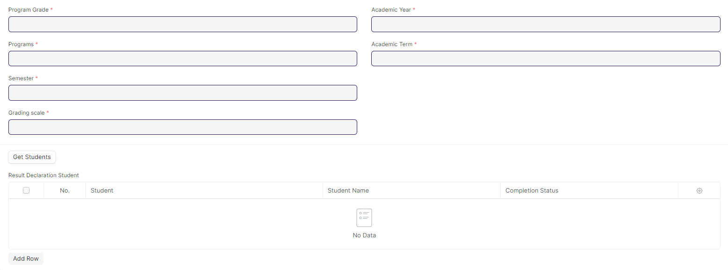

#### **Business Requirements:**

* No changes needed as discussed.

### **Cumulative Mark sheet Tool**

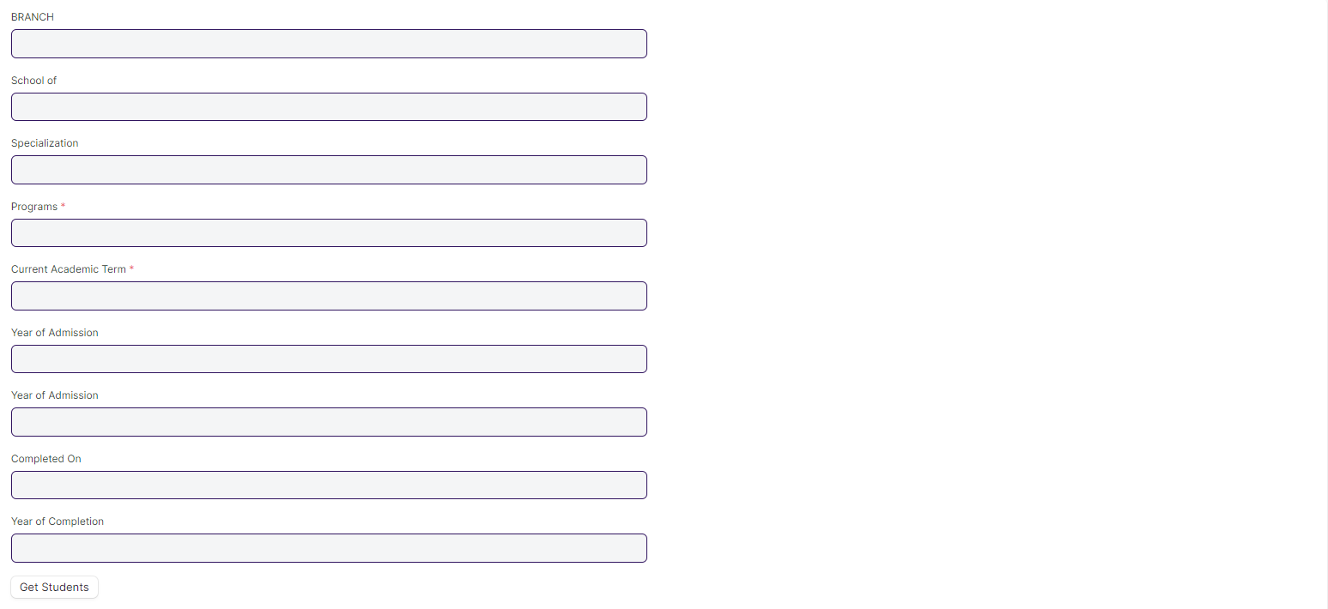

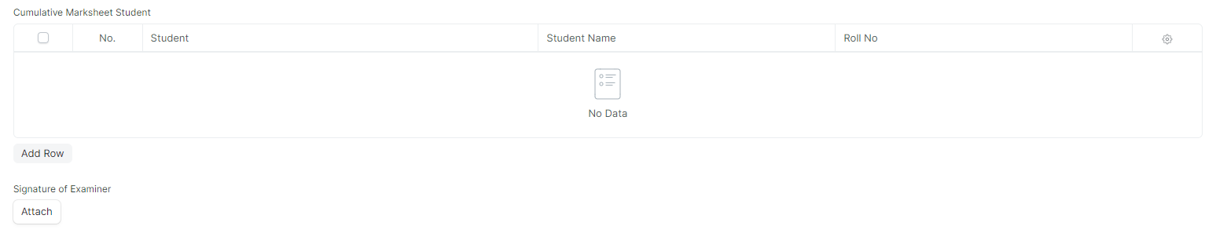

#### **Business Requirements:**

* Remove/Hide the CGPA, SGPA, and Credit features from the Cumulative Mark sheet and display the percentage and grade instead.

### **Provisional Certificate Tool**

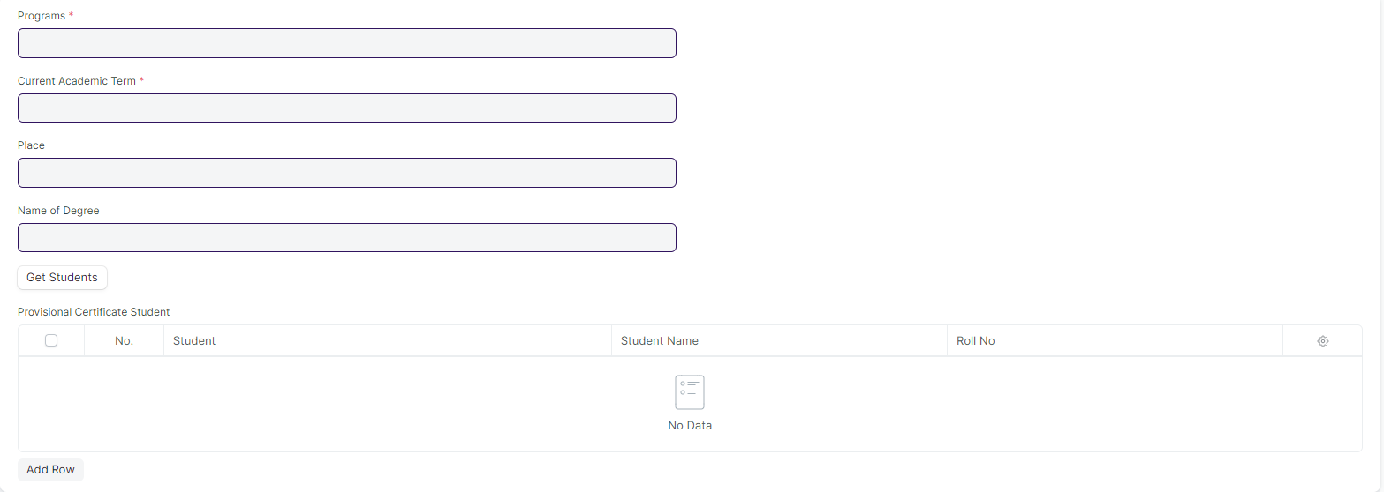

#### **Business Requirements:**

* No changes needed as discussed.

### **Migration Certificate Tool**

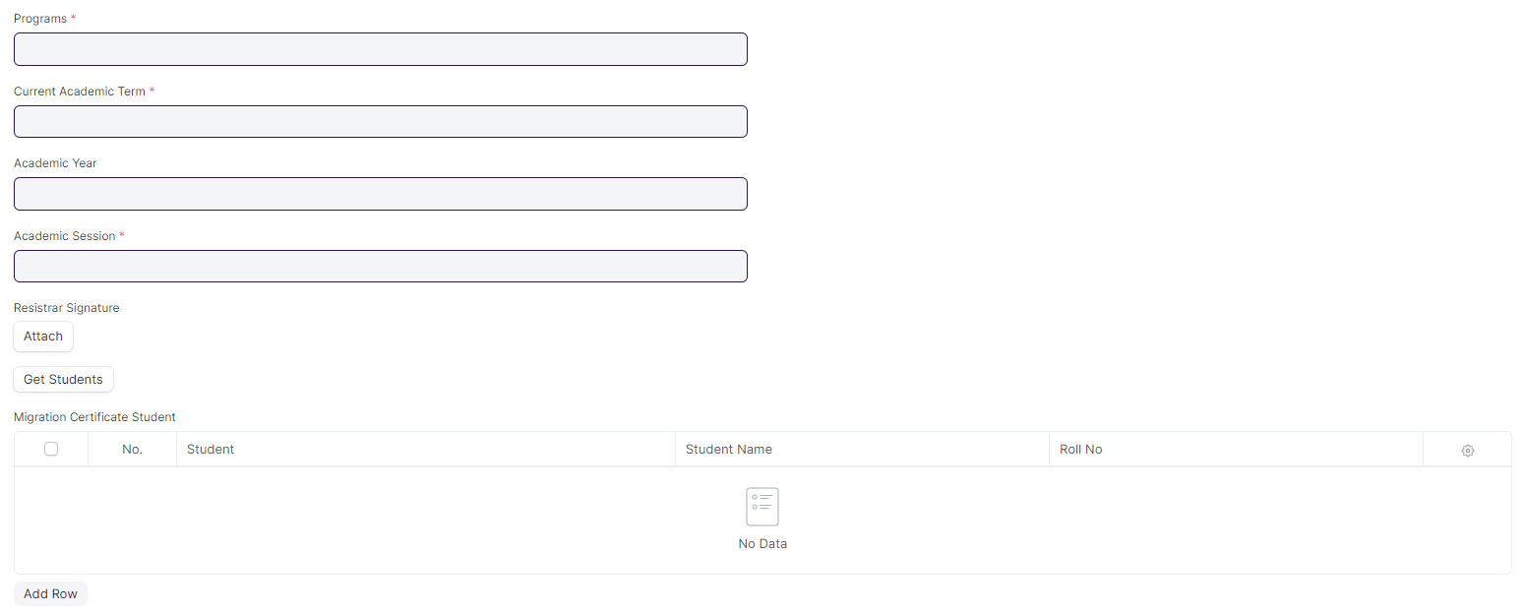

#### **Business Requirements:**

* Label Renaming is required for Program to Course.

### **Conduct Certificate Tool**

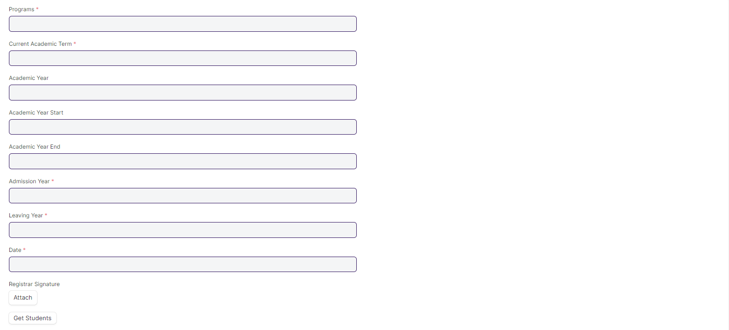

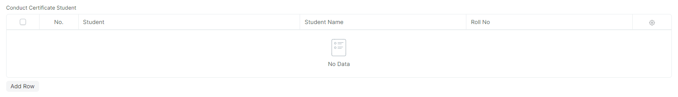

#### **Business Requirements:**

* Label Renaming is required for Program to Course.

## **Transcripts**

### **Leaving Certificate**

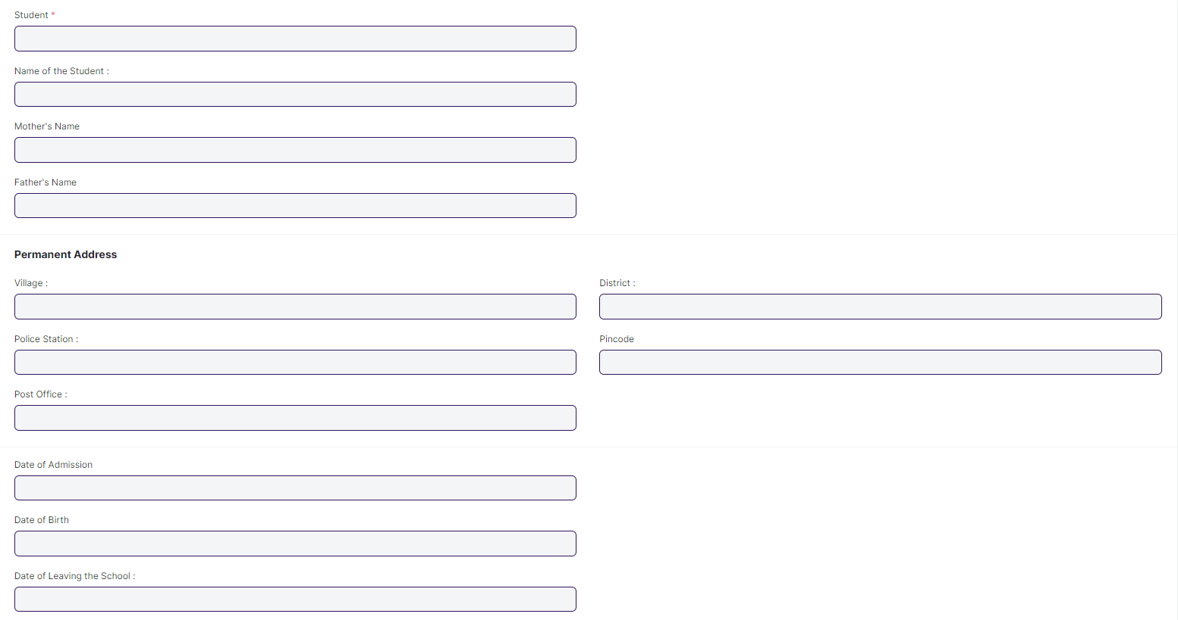

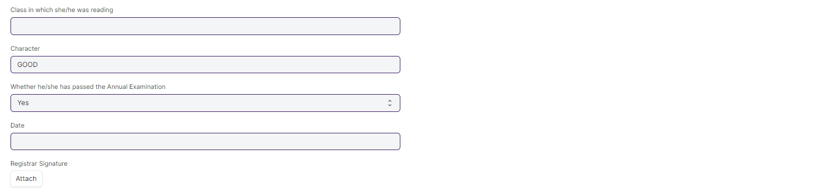

#### **Business Requirements:**

* Label Renaming is required for Program to Course.

### **Provisional Certificate**

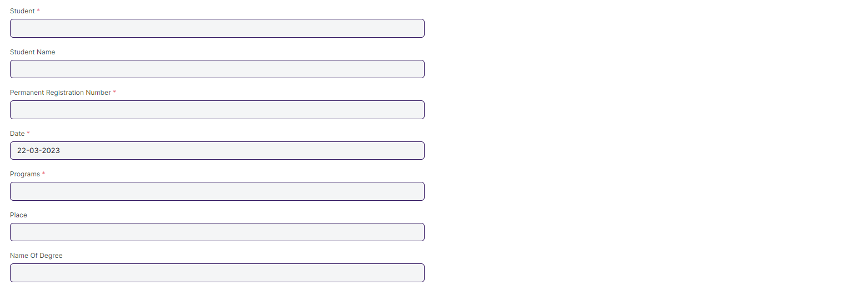

#### **Business Requirements:**

* Label Renaming is required for Program to Course.

### **Migration Certificate**

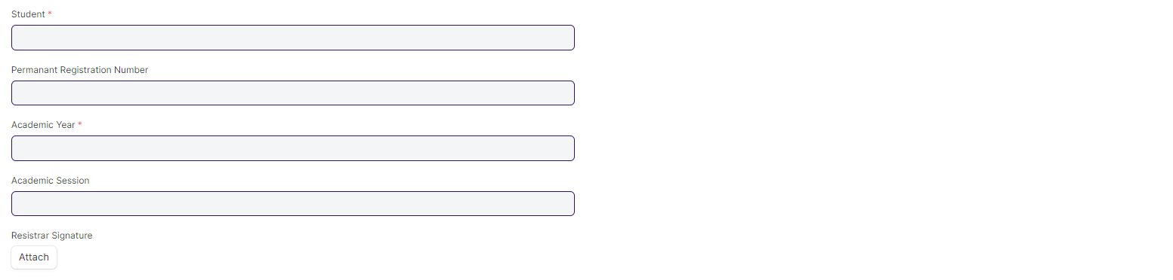

#### **Business Requirements:**

* No changes needed as discussed.

### **Conduct Certificate**

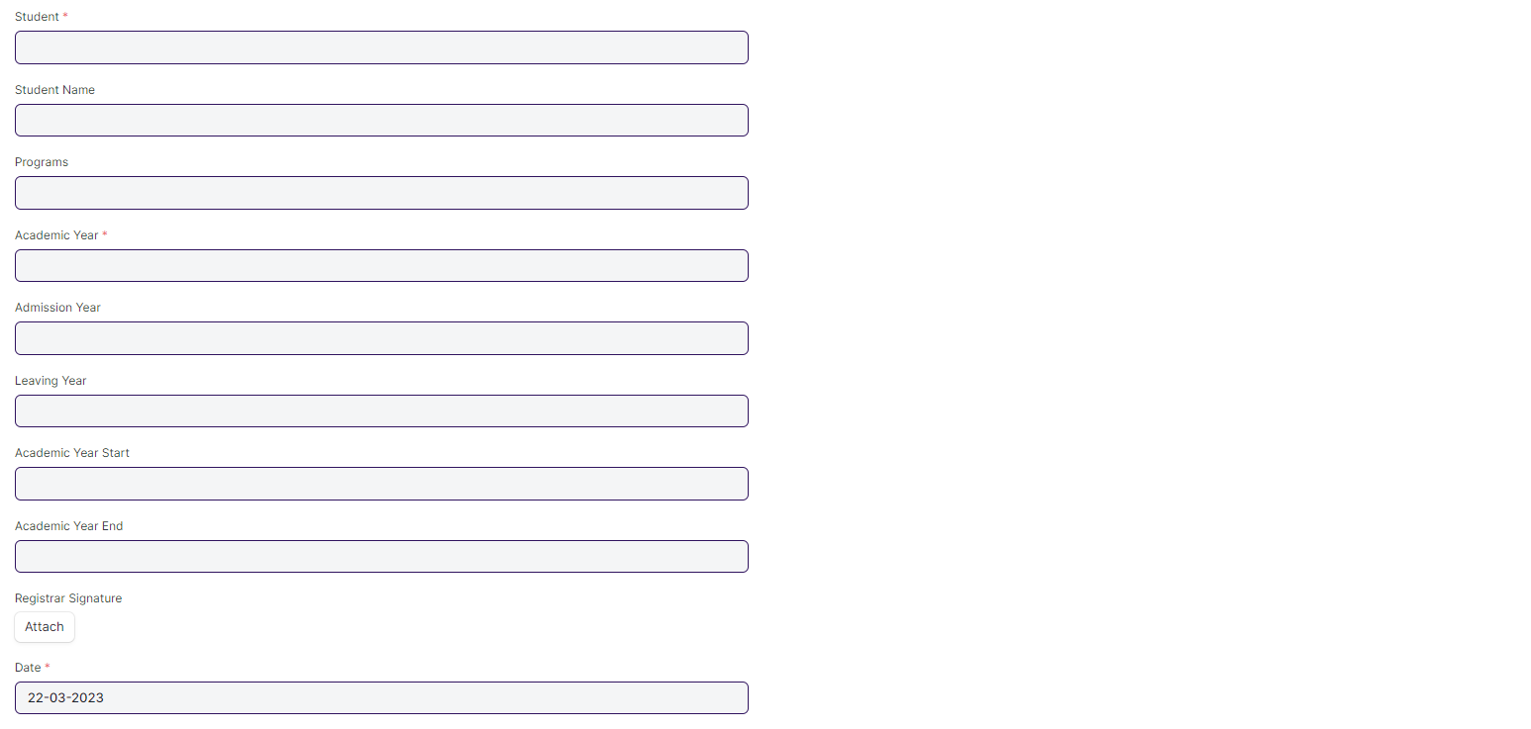

#### **Business Requirements:**

* Label Renaming is required for Program to Course.

### **Cumulative Marksheet**

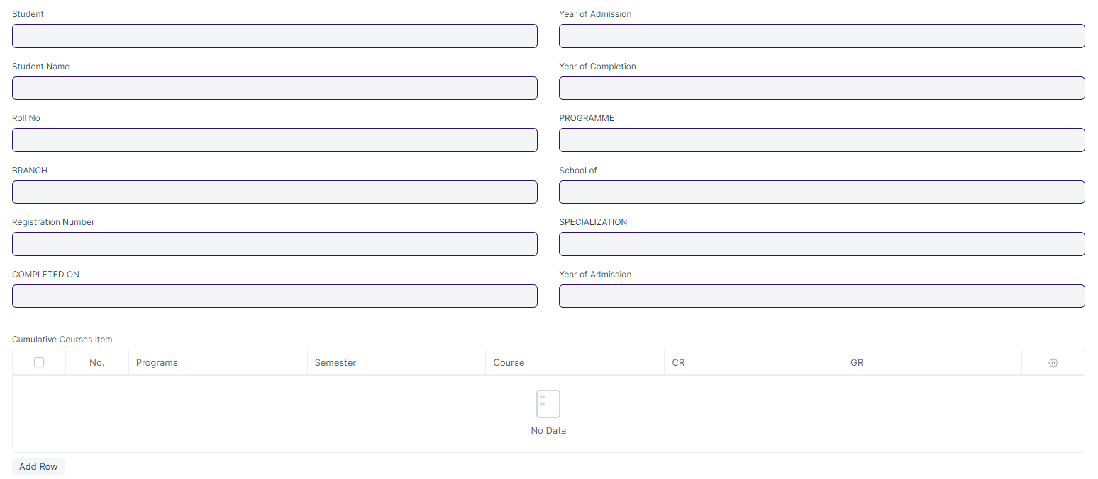

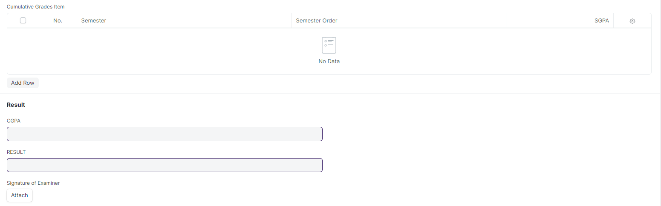

#### **Business Requirements:**

* Remove/Hide the CGPA, SGPA, and Credit features from the Cumulative Mark sheet and display the percentage and grade instead.
* Renaming of labels is required in Cumulative Courses Item child table for Course, Course Name, and Course Code to Module, Module Name, and Module Code respectively.
* Deletion of “Overall grade” Field and “Grade” Field in Cumulative Grades Item child table.